**Exercise 3: Stored Procedures**

**Scenario 1:** The bank needs to process monthly interest for all savings accounts.

**Question:** Write a stored procedure **ProcessMonthlyInterest** that calculates and updates the balance of all savings accounts by applying an interest rate of 1% to the current balance.

SET SERVEROUTPUT ON;

CREATE OR REPLACE PROCEDURE ProcessMonthlyInterest AS

v_count NUMBER := 0;

v_total_interest NUMBER := 0;

BEGIN

SELECT COUNT(*), NVL(SUM(Balance * 0.01), 0)

INTO v_count, v_total_interest

FROM Accounts

WHERE UPPER(AccountType) = 'SAVINGS';

DBMS_OUTPUT.PUT_LINE('PROCESSING MONTHLY INTEREST');

DBMS_OUTPUT.PUT_LINE('Found ' || v_count || ' savings accounts');

IF v_count > 0 THEN

UPDATE Accounts

SET Balance = Balance * 1.01,

LastModified = SYSDATE

WHERE UPPER(AccountType) = 'SAVINGS';

COMMIT;

DBMS_OUTPUT.PUT_LINE('Interest rate applied: 1%');

DBMS_OUTPUT.PUT_LINE('Total interest added: $' || ROUND(v_total_interest, 2));

DBMS_OUTPUT.PUT_LINE('SUCCESS: Monthly interest processed for all savings accounts');

ELSE

DBMS_OUTPUT.PUT_LINE('No savings accounts found to process');

END IF;

END ProcessMonthlyInterest;

/

*-- Test the procedure*

BEGIN

ProcessMonthlyInterest;

END;

/

**OUTPUT:**

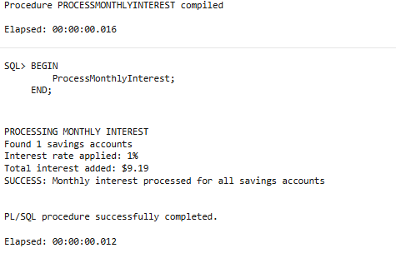

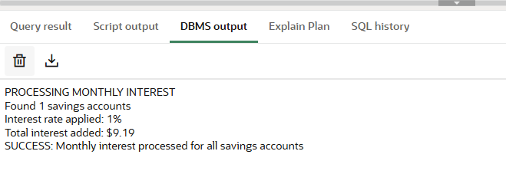

**Scenario 2:** The bank wants to implement a bonus scheme for employees based on their performance.

**Question:** Write a stored procedure **UpdateEmployeeBonus** that updates the salary of employees in each department by adding a bonus percentage passed as a parameter.

SET SERVEROUTPUT ON;

CREATE OR REPLACE PROCEDURE UpdateEmployeeBonus(

p_department IN VARCHAR2,

p_bonus_percentage IN NUMBER

) AS

v_count NUMBER := 0;

v_total_bonus NUMBER := 0;

v_old_salary_total NUMBER := 0;

v_new_salary_total NUMBER := 0;

BEGIN

DBMS_OUTPUT.PUT_LINE('PROCESSING EMPLOYEE BONUS');

DBMS_OUTPUT.PUT_LINE('Department: ' || p_department);

DBMS_OUTPUT.PUT_LINE('Bonus Percentage: ' || p_bonus_percentage || '%');

SELECT COUNT(*), NVL(SUM(Salary), 0), NVL(SUM(Salary * (p_bonus_percentage/100)), 0)

INTO v_count, v_old_salary_total, v_total_bonus

FROM Employees

WHERE UPPER(Department) = UPPER(p_department);

DBMS_OUTPUT.PUT_LINE('Employees found in ' || p_department || ': ' || v_count);

IF v_count > 0 THEN

DBMS_OUTPUT.PUT_LINE('Total current salary: $' || v_old_salary_total);

DBMS_OUTPUT.PUT_LINE('Total bonus amount: $' || ROUND(v_total_bonus, 2));

UPDATE Employees

SET Salary = Salary + (Salary * (p_bonus_percentage/100))

WHERE UPPER(Department) = UPPER(p_department);

v_new_salary_total := v_old_salary_total + v_total_bonus;

COMMIT;

DBMS_OUTPUT.PUT_LINE('SUCCESS: Bonus applied to ' || v_count || ' employees');

DBMS_OUTPUT.PUT_LINE('New total salary: $' || ROUND(v_new_salary_total, 2));

ELSE

DBMS_OUTPUT.PUT_LINE('No employees found in department: ' || p_department);

END IF;

END UpdateEmployeeBonus;

/

-- Test the procedure with HR department (10% bonus)

BEGIN

UpdateEmployeeBonus('HR', 10);

END;

/

-- Test with IT department (5% bonus)

BEGIN

UpdateEmployeeBonus('IT', 5);

END;

/

-- Test with non-existing department

BEGIN

UpdateEmployeeBonus('FINANCE', 15);

END;/

**OUTPUT:**

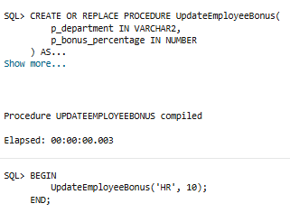

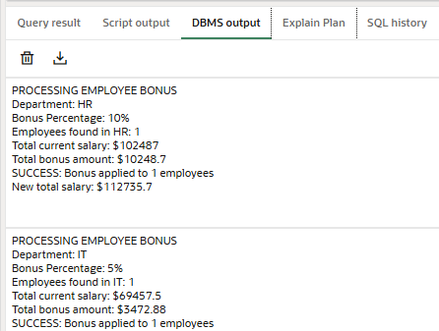

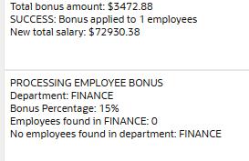

**Scenario 3:** Customers should be able to transfer funds between their accounts.

**Question:** Write a stored procedure **TransferFunds** that transfers a specified amount from one account to another, checking that the source account has sufficient balance before making the transfer.

SET SERVEROUTPUT ON;

CREATE OR REPLACE PROCEDURE TransferFunds(

p_from_account IN NUMBER,

p_to_account IN NUMBER,

p_amount IN NUMBER

) AS

v_from_balance NUMBER;

v_to_balance NUMBER;

v_transaction_id NUMBER;

v_from_customer NUMBER;

v_to_customer NUMBER;

v_from_count NUMBER := 0;

v_to_count NUMBER := 0;

BEGIN

DBMS_OUTPUT.PUT_LINE('PROCESSING FUND TRANSFER ');

DBMS_OUTPUT.PUT_LINE('From Account ID: ' || p_from_account);

DBMS_OUTPUT.PUT_LINE('To Account ID: ' || p_to_account);

DBMS_OUTPUT.PUT_LINE('Transfer Amount: $' || p_amount);

SELECT COUNT(*) INTO v_from_count

FROM Accounts

WHERE AccountID = p_from_account;

SELECT COUNT(*) INTO v_to_count

FROM Accounts

WHERE AccountID = p_to_account;

IF v_from_count = 0 THEN

DBMS_OUTPUT.PUT_LINE('ERROR: Source account ' || p_from_account || ' does not exist');

RETURN;

END IF;

IF v_to_count = 0 THEN

DBMS_OUTPUT.PUT_LINE('ERROR: Destination account ' || p_to_account || ' does not exist');

RETURN;

END IF;

SELECT Balance, CustomerID

INTO v_from_balance, v_from_customer

FROM Accounts

WHERE AccountID = p_from_account;

SELECT Balance, CustomerID

INTO v_to_balance, v_to_customer

FROM Accounts

WHERE AccountID = p_to_account;

DBMS_OUTPUT.PUT_LINE('Source account balance: $' || v_from_balance);

DBMS_OUTPUT.PUT_LINE('Destination account balance: $' || v_to_balance);

IF v_from_balance >= p_amount THEN

DBMS_OUTPUT.PUT_LINE('Sufficient balance available. Processing transfer...');

UPDATE Accounts

SET Balance = Balance - p_amount,

LastModified = SYSDATE

WHERE AccountID = p_from_account;

UPDATE Accounts

SET Balance = Balance + p_amount,

LastModified = SYSDATE

WHERE AccountID = p_to_account;

SELECT NVL(MAX(TransactionID), 0) + 1 INTO v_transaction_id FROM Transactions;

INSERT INTO Transactions (TransactionID, AccountID, TransactionDate, Amount, TransactionType)

VALUES (v_transaction_id, p_from_account, SYSDATE, p_amount, 'Transfer Out');

INSERT INTO Transactions (TransactionID, AccountID, TransactionDate, Amount, TransactionType)

VALUES (v_transaction_id + 1, p_to_account, SYSDATE, p_amount, 'Transfer In');

COMMIT;

DBMS_OUTPUT.PUT_LINE('SUCCESS: Transfer completed!');

DBMS_OUTPUT.PUT_LINE('New balance in Account ' || p_from_account || ': $' || (v_from_balance - p_amount));

DBMS_OUTPUT.PUT_LINE('New balance in Account ' || p_to_account || ': $' || (v_to_balance + p_amount));

DBMS_OUTPUT.PUT_LINE('Transaction IDs created: ' || v_transaction_id || ', ' || (v_transaction_id + 1));

ELSE

DBMS_OUTPUT.PUT_LINE('FAILED: Insufficient balance');

DBMS_OUTPUT.PUT_LINE('Required amount: $' || p_amount);

DBMS_OUTPUT.PUT_LINE('Available balance: $' || v_from_balance);

DBMS_OUTPUT.PUT_LINE('Shortfall: $' || (p_amount - v_from_balance));

END IF;

END TransferFunds;

/

-- Test the procedure

BEGIN

-- Test 1: Valid transfer

TransferFunds(1, 2, 100);

END;

/

BEGIN

-- Test 2: Insufficient balance

TransferFunds(1, 2, 50000);

END;

/

BEGIN

-- Test 3: Invalid source account

TransferFunds(999, 2, 100);

END;

/

BEGIN

-- Test 4: Invalid destination account

TransferFunds(1, 999, 100);

END;

/

**OUTPUT:**

